

Teacher Box

|  |  |  |  |
| --- | --- | --- | --- |
| Date: |  | Time: |  |

**[mascot] Problem Solver**



**Your Mascot Image Here**

Name:

**What happened?**

|  |  |  |
| --- | --- | --- |
| **My Brain said:** | **My Body did:** | **Now! My heart feels:** |

**My actions bothered/hurt: (circle)**

|  |  |  |  |  |  |
| --- | --- | --- | --- | --- | --- |
| **Myself** |  | **My Classmates** |  | **An Adult** | **School Property** |
|  |  |  |  |  |  |

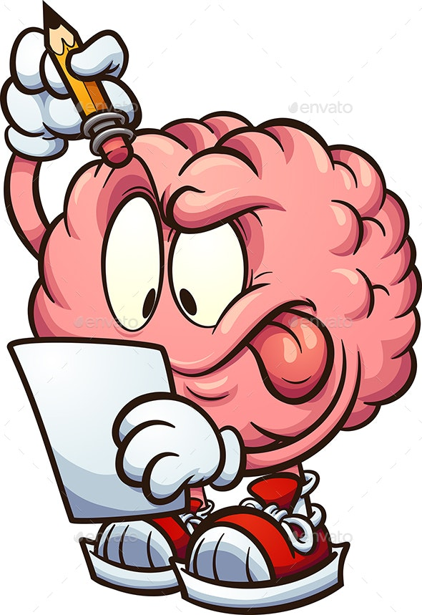

**How are you going to fix it?**

|  |  |  |  |  |  |  |
| --- | --- | --- | --- | --- | --- | --- |
| **Apology** |  | **Clean up** |  | **Refocus Break** |  | **Other** |
| **Grinning face with solid fill with solid fillPencil outline** |  | **Mop and bucket outline** |  | Stopwatch 33% with solid fillCouch outline |  | **Lunch Box with solid fill Pencil outline** |

**I am ready to Be A Learner! Yes No**